Appendix A

This appendix contains the collection of visuals deemed too large to fit in the body text of the paper, but detail important temporal properties of bias and misinformation patterns. The visuals were derived from the accompanying organizational datasets, which are available for further verification and research.

# 2016 Presidential Candidate Content Volume

Coverage volume plots for the following topic sets: $t1=\left\{donald, trump\right\}$ and $t2=\{clinton,hillary\}$. One of these terms is chosen for display in each legend. The numbers in the legend represent total topical content volume. These volumes are measured after filtering of duplicate content and topical cross-filtering, hence correspond to the inputs used for sentiment analysis.

## ABC News

## BBC

## CBS News

## CNN

## Fox News

## Google News

## The Hill

## MSN News

## NBC News

## NPR

## Politico

## Russia Today (RT)

## Sputnik News

## Time

## USA Today

## The Washington Post

## The Wall Street Journal (WSJ)

## Yahoo News

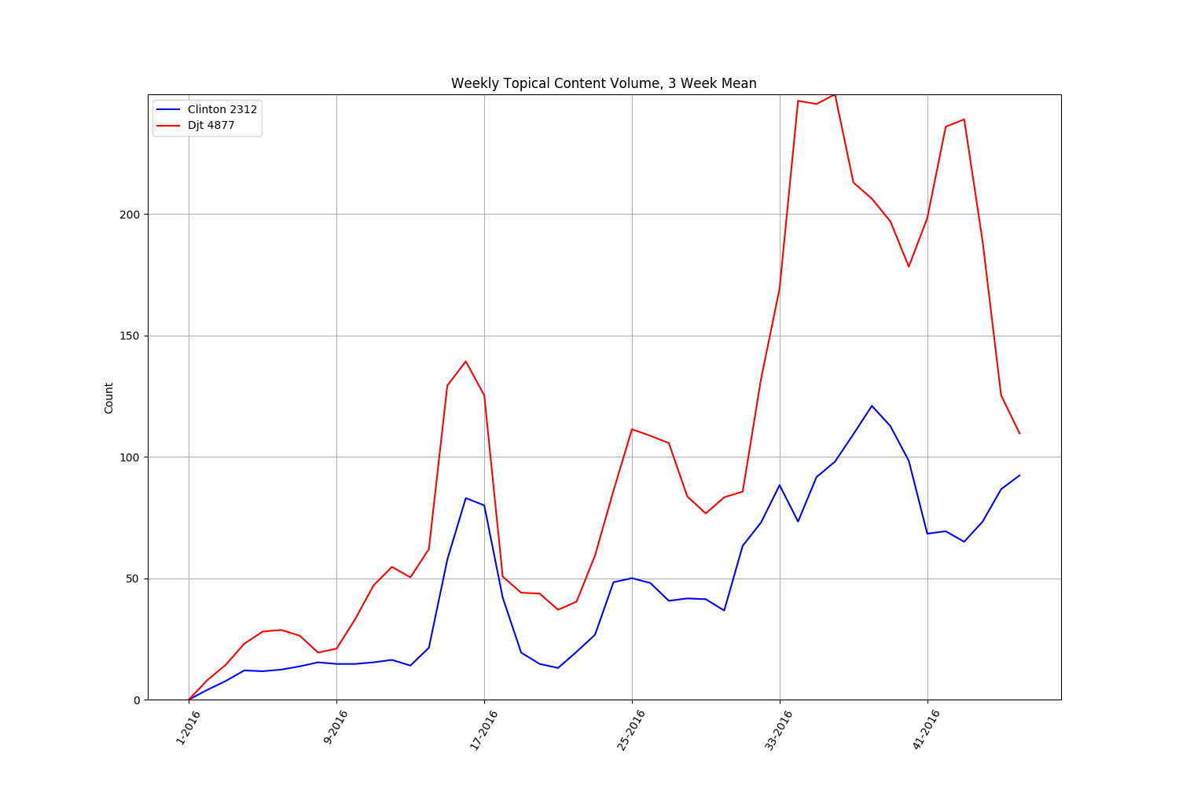

# 2016 Presidential Candidate PPMI-Based Sentiment Analysis

PPMI sentiment analyses of candidate topic sets $t1=\left\{donald,trump,djt\right\}$ and $t2=\left\{clinton,hillary,hrc\right\}$.

## ABC News

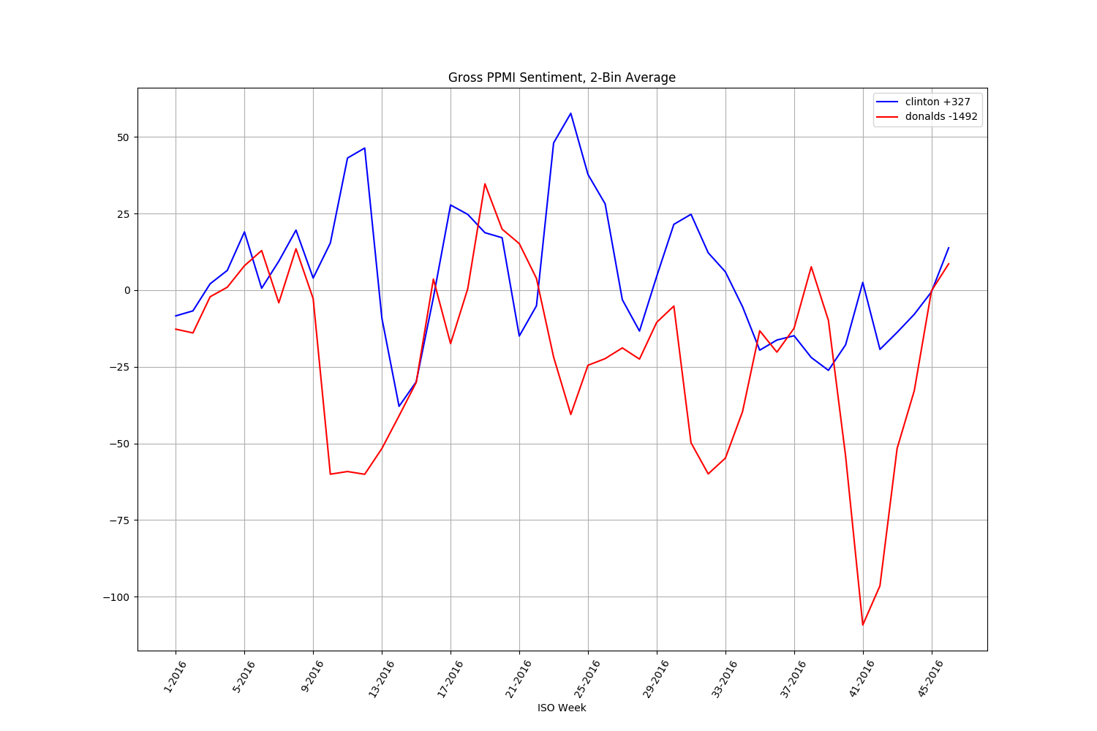

## BBC

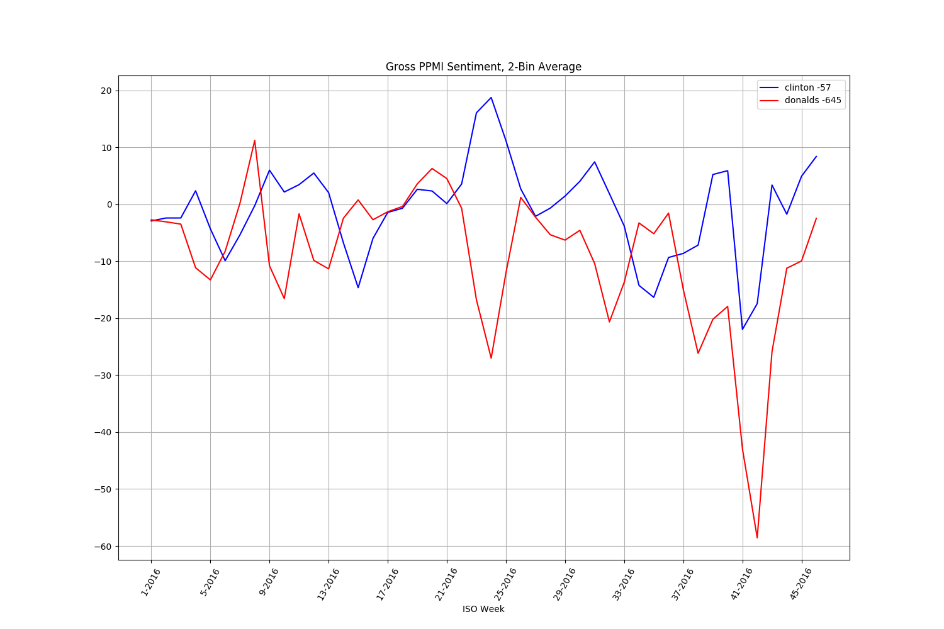

## CBS News

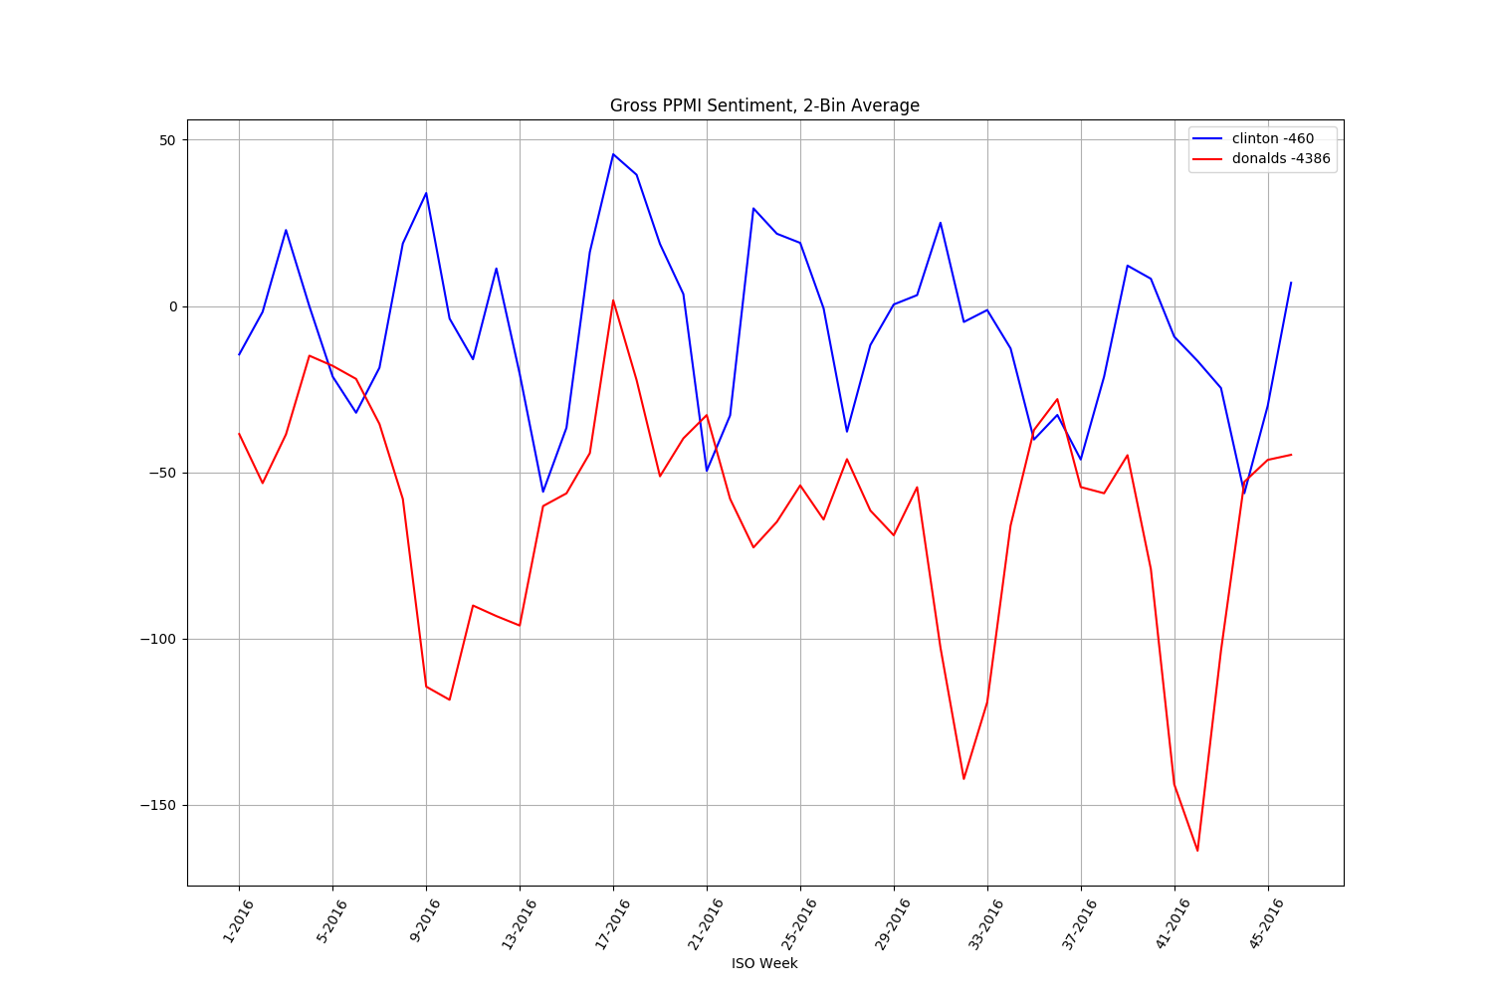

## CNN

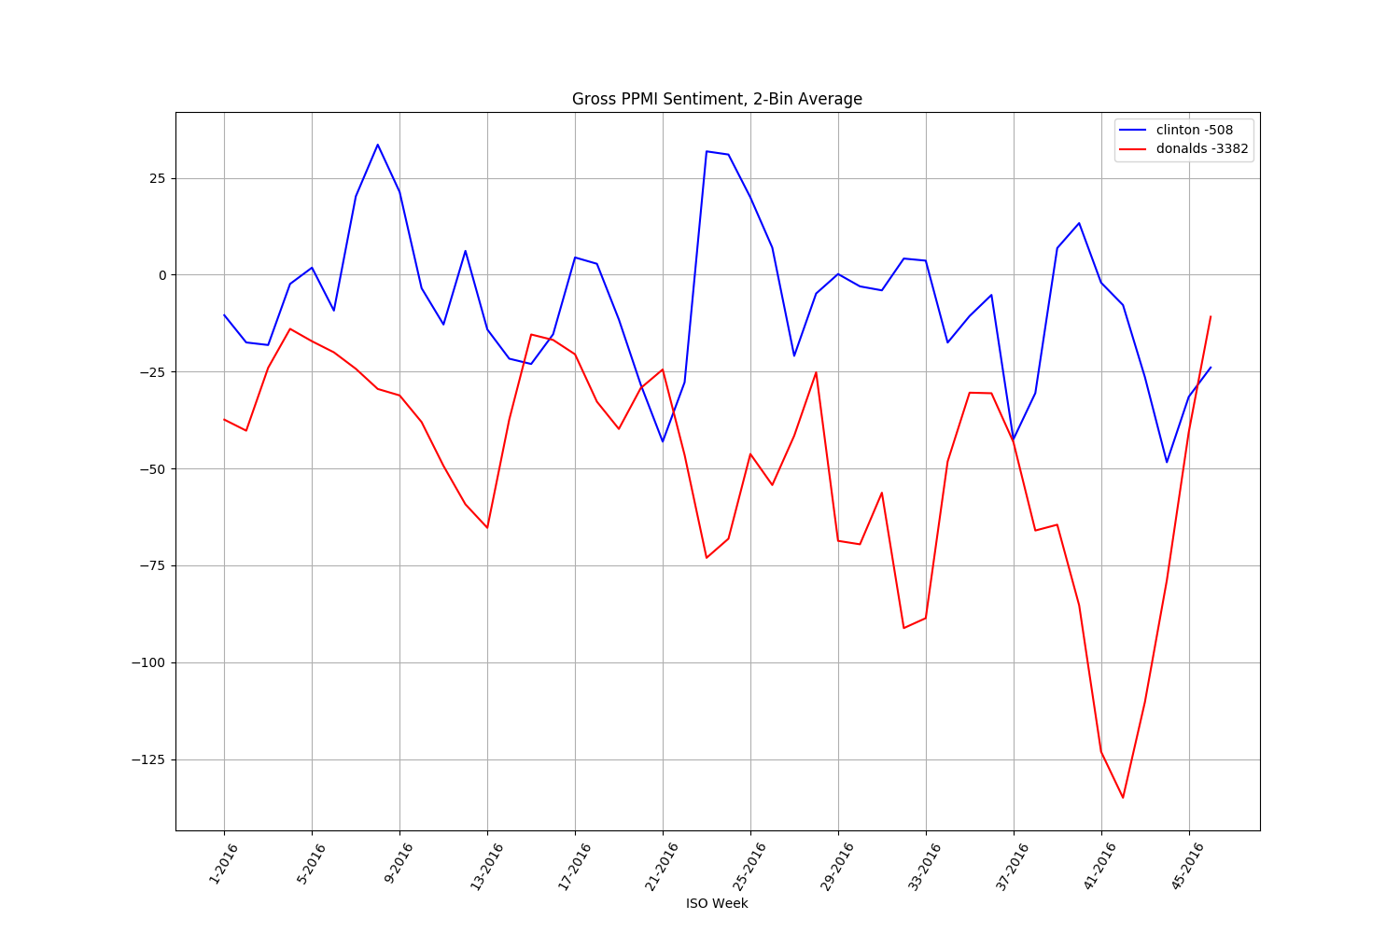

## Fox News

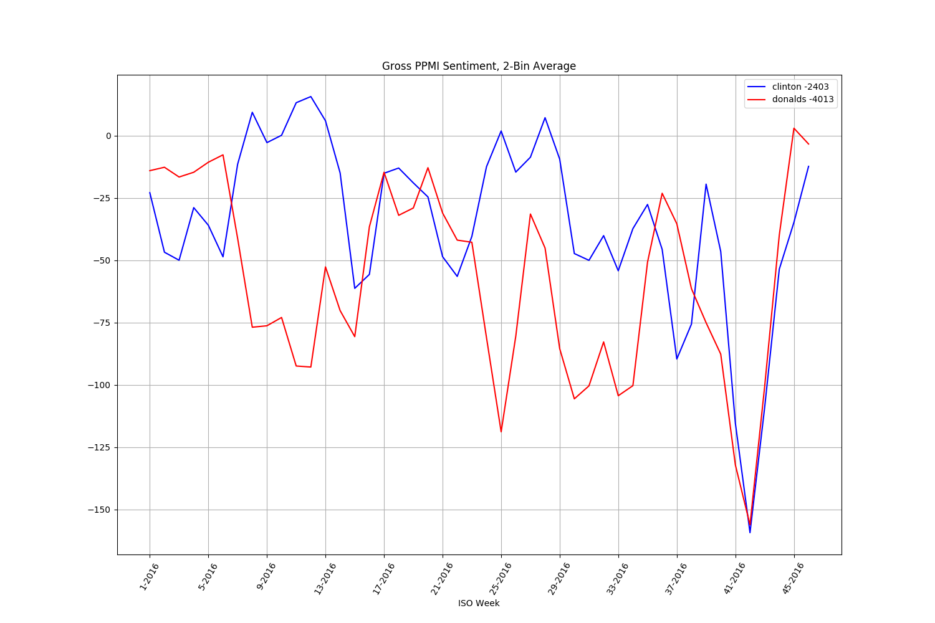

## Google News

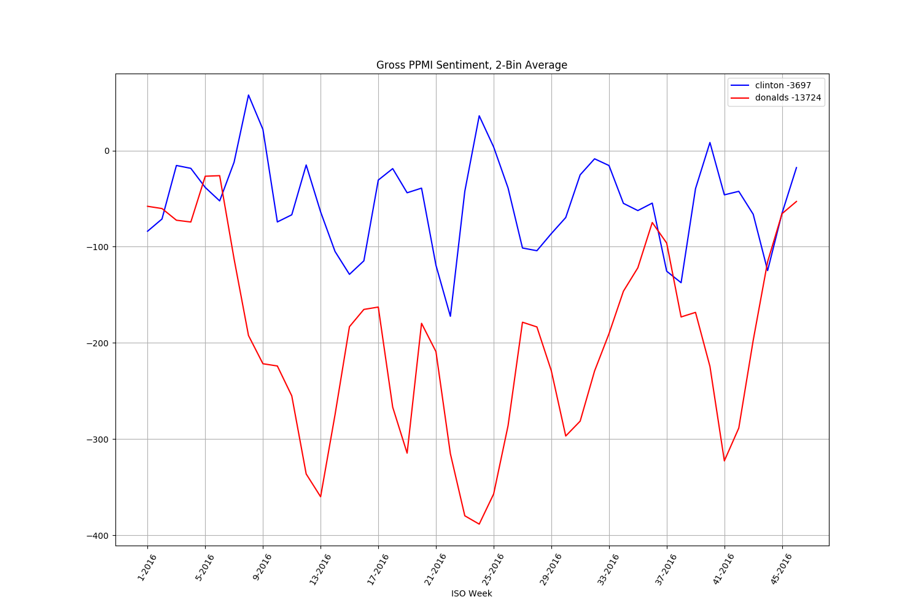

## The Hill

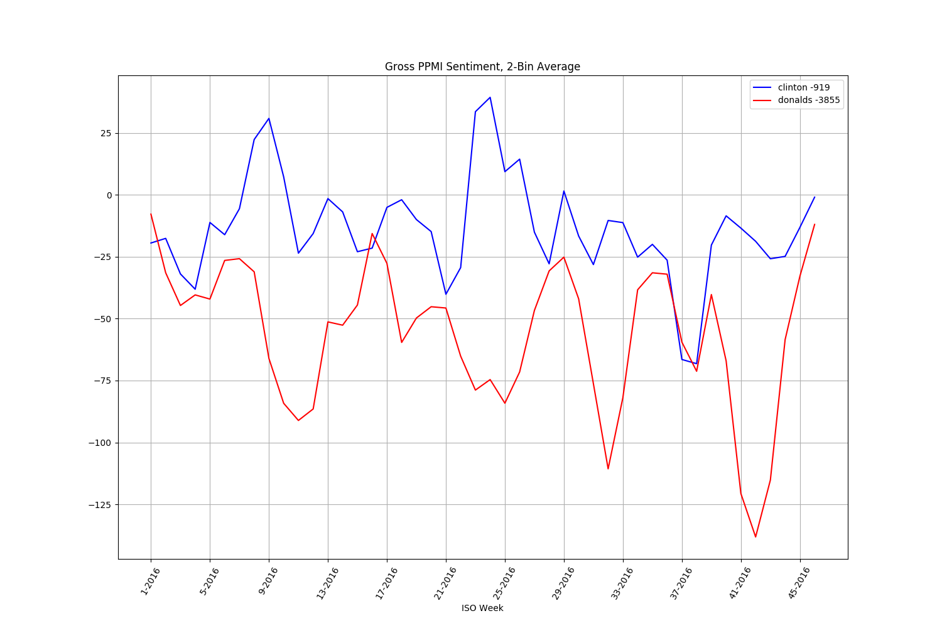

## MSN News

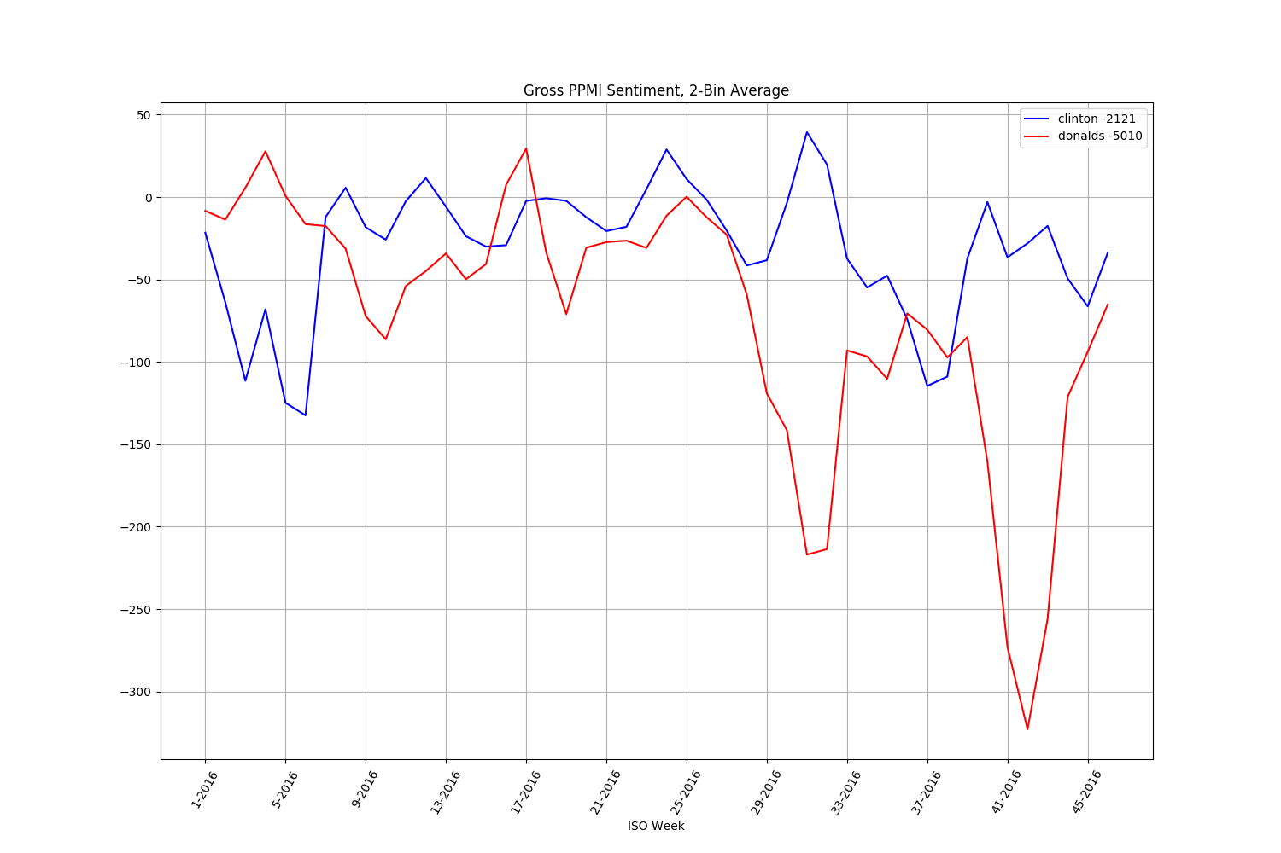

## NBC News

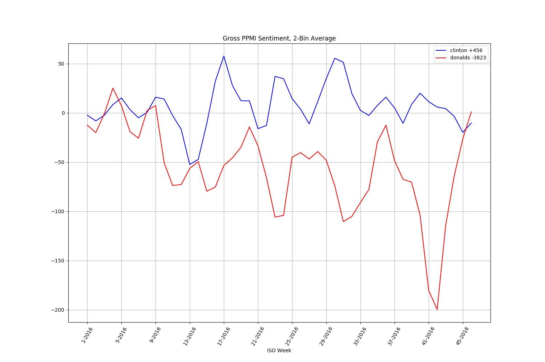

## NPR

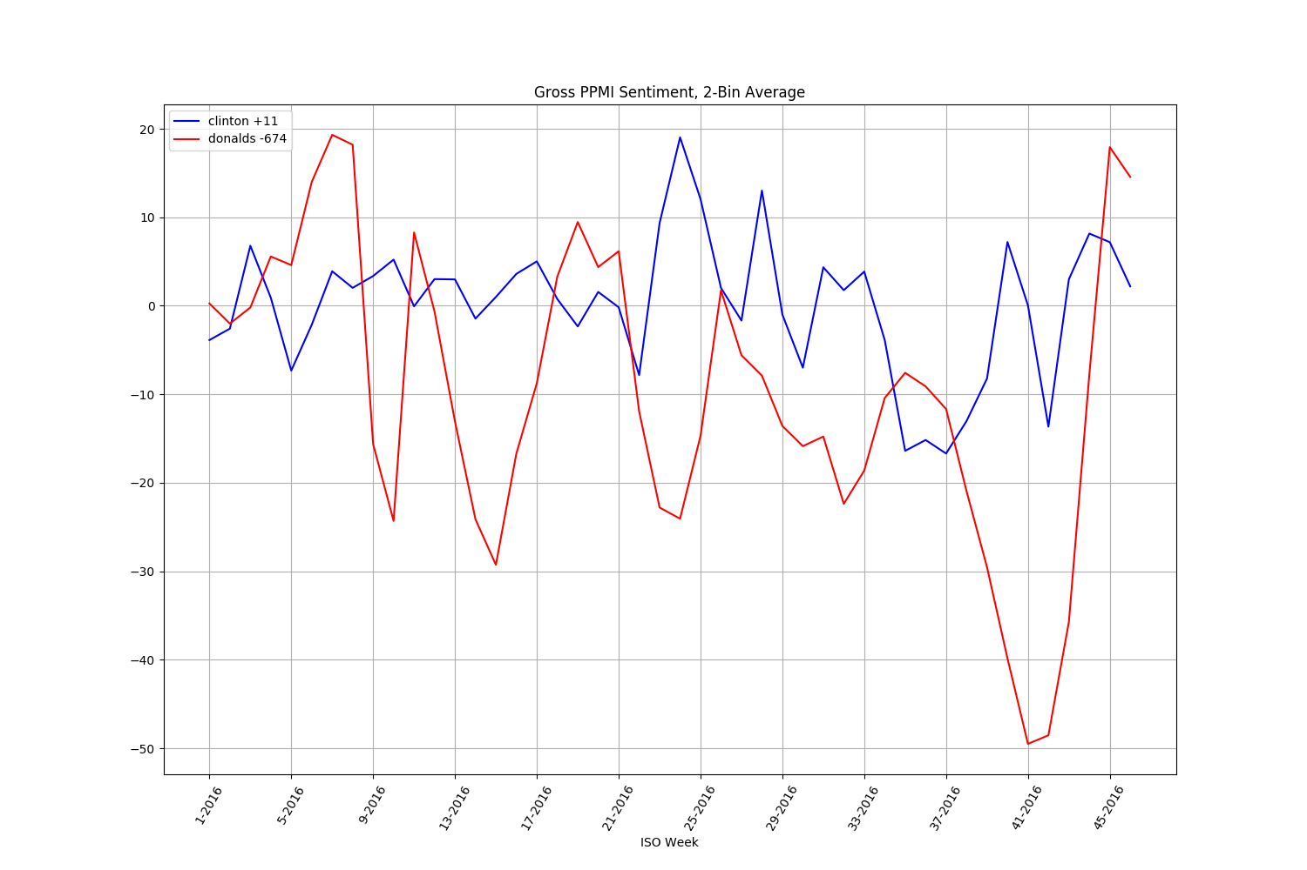

## Politico

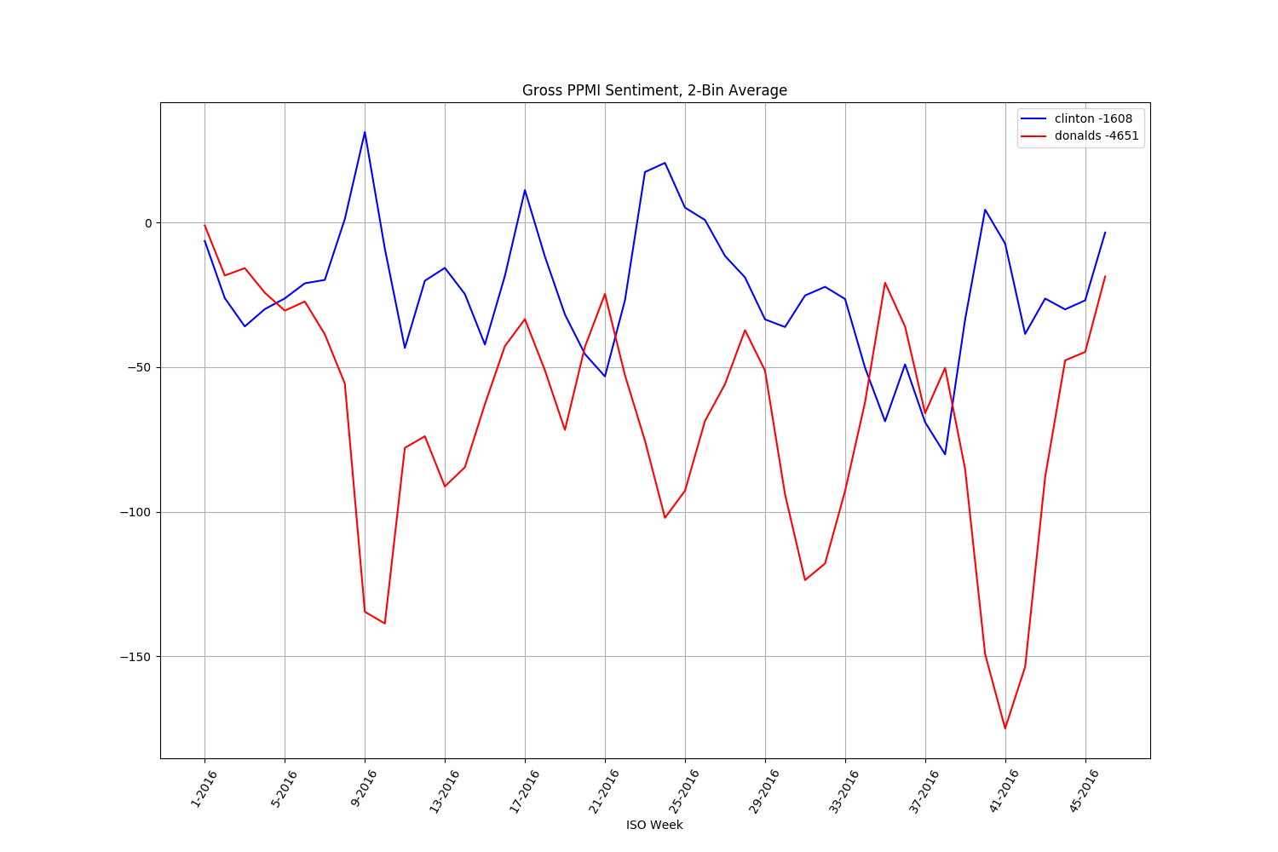

## Russia Today (RT)

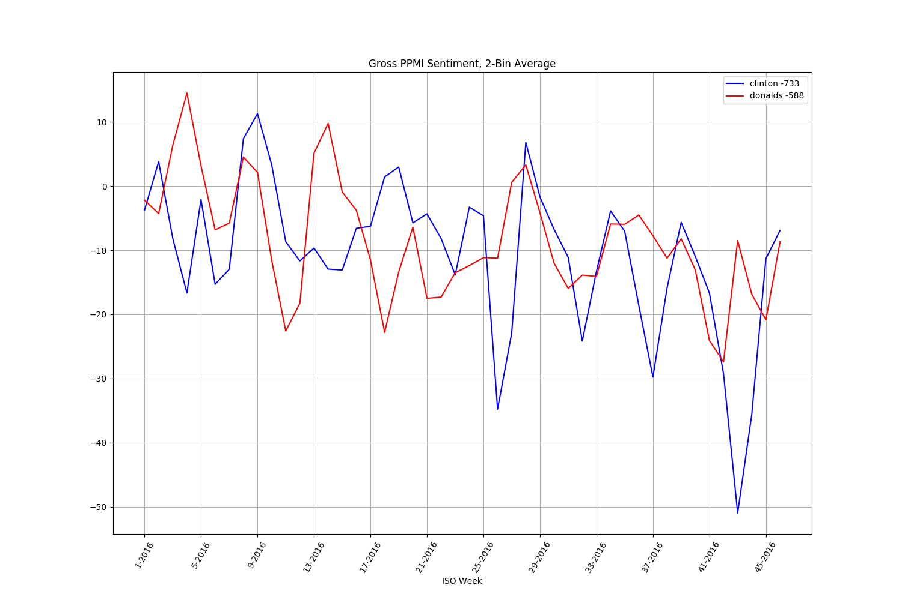

## Sputnik News

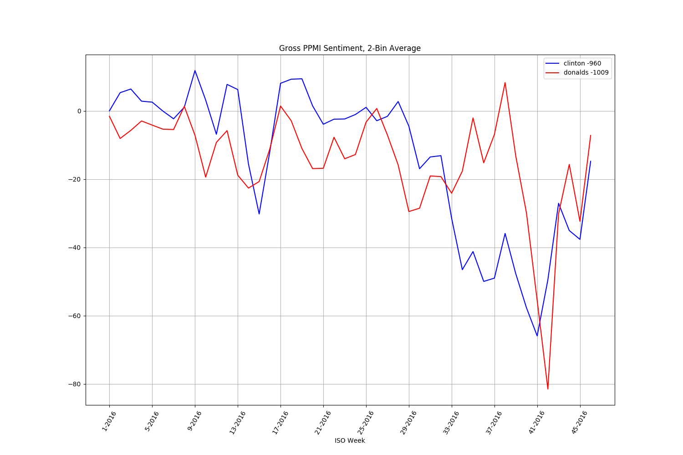

## Time

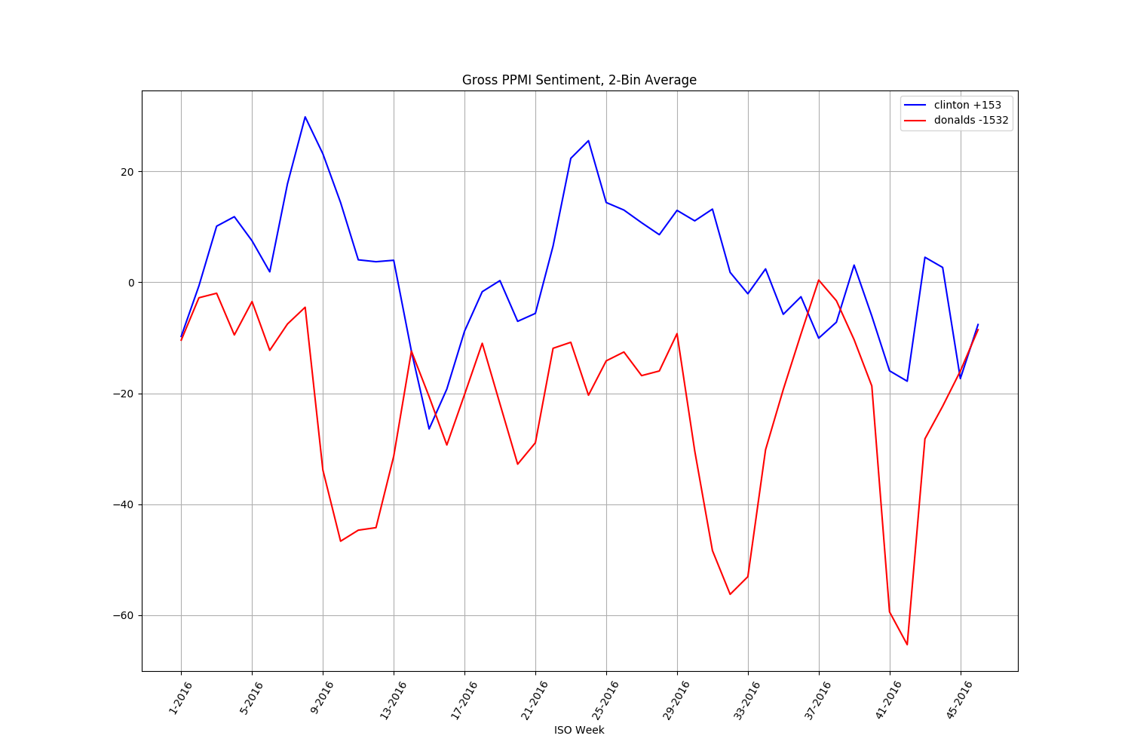

## USA Today

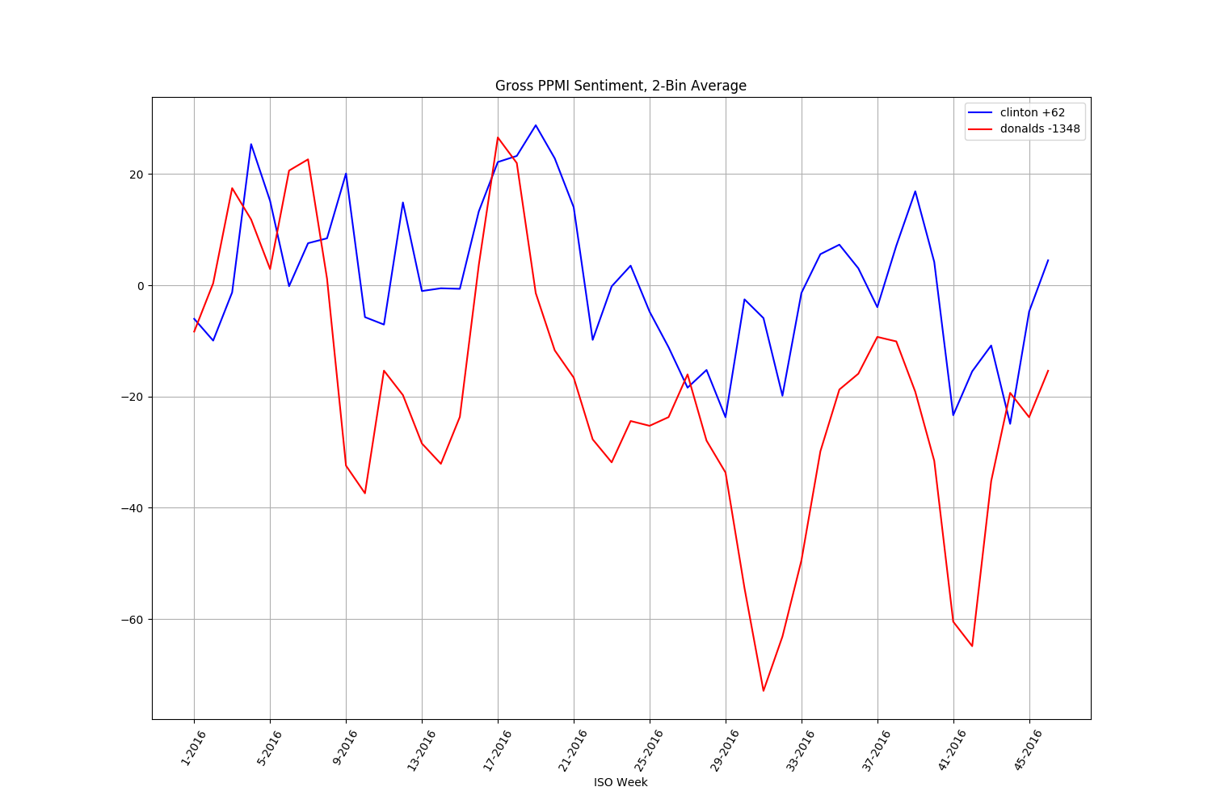

## The Washington Post

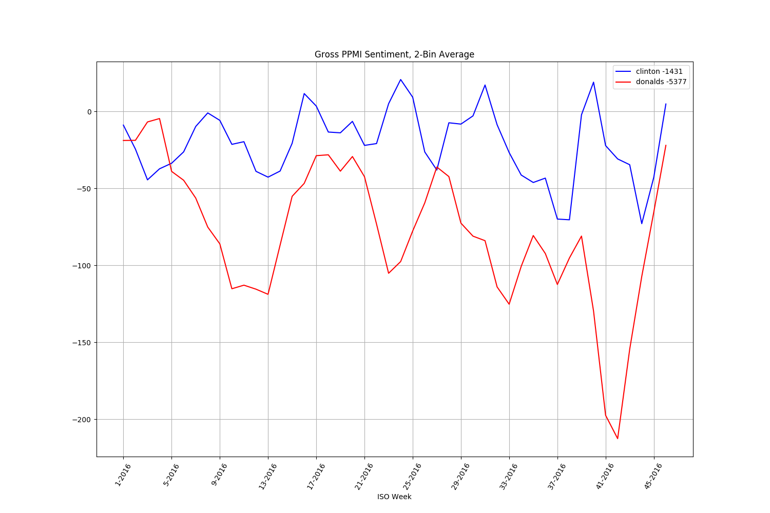

## The Wall Street Journal

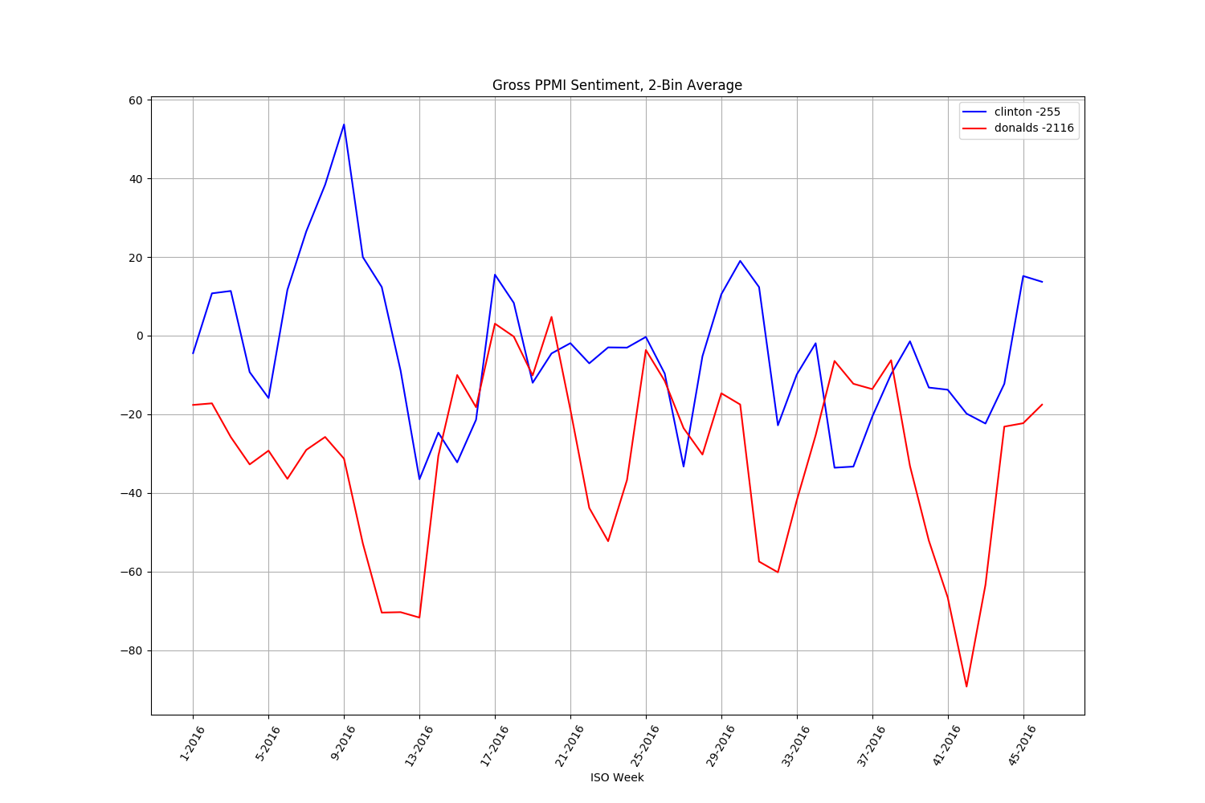

## Yahoo News

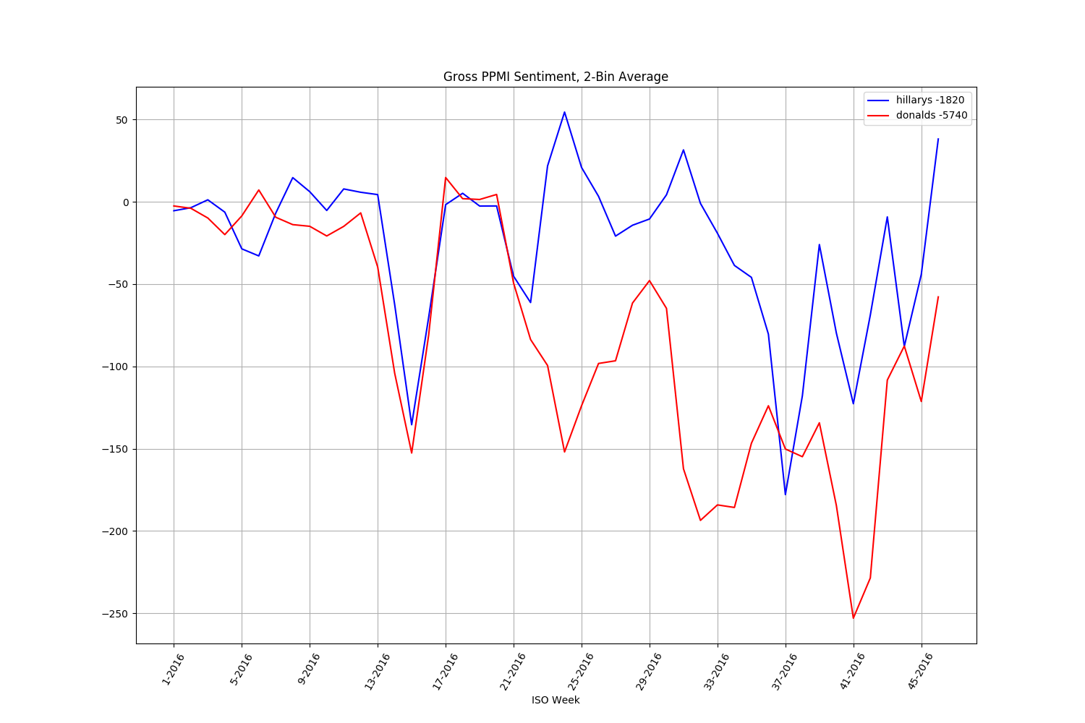

# 2016 Partisan Content Volume

Coverage volume plots for the following topic sets: $t3=\left\{democrat, liberal,progressive,dnc\right\}$ and $t4=\{republican,conservative,gop,rnc\}$. One of these terms is chosen for display in each legend. The numbers in the legend represent total topical content volume. These volumes are measured after filtering of duplicate content and topical cross-filtering, hence correspond to the inputs used for sentiment analysis.

## ABC News

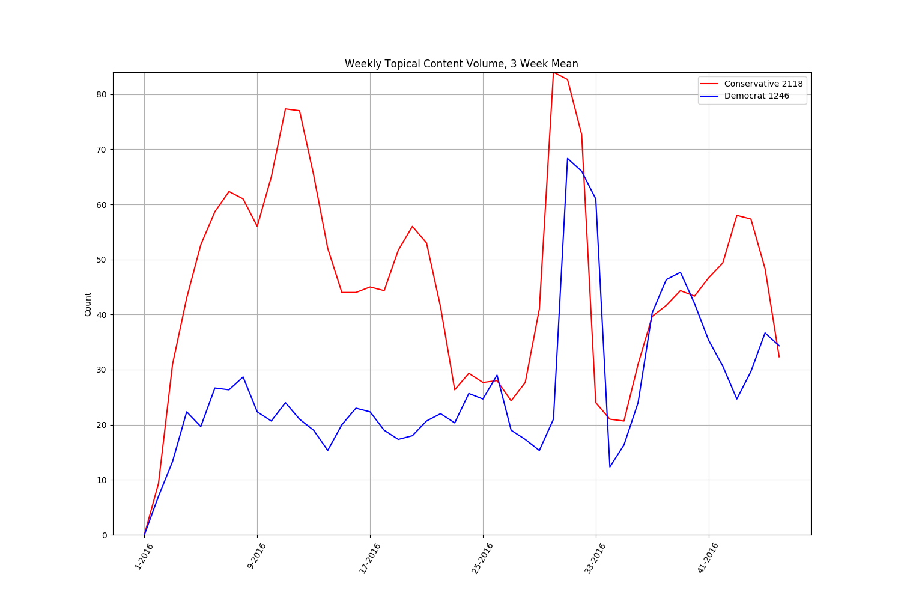

## BBC

## CBS

## CNN

## Fox News

## Google News

## The Hill

## MSN News

## NBC News

## NPR

## Politico

## Russia Today (RT)

## Sputnik News

## Time

## USA Today

## The Washington Post

## The Wall Street Journal

## Yahoo News

# 2016 Partisan Sentiment Analysis

## ABC News

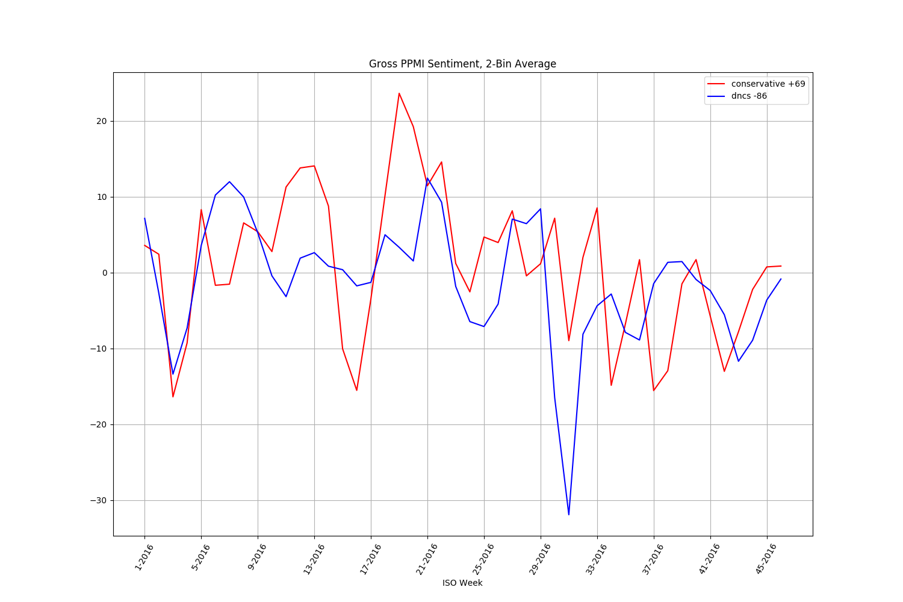

## BBC

## CBS News

## CNN

## Fox News

## Google News

## The Hill

## MSN

## NBC

## NPR

## Politico

## Russia Today (RT)Sputnik News

## Time

## USA Today

## The Wall Street Journal

## The Washington Post

## Yahoo New

Google News Partisan Sentiment Analysis

Long term partisan analysis of Google News content, for topics $t3=\left\{democrat, liberal,progressive,dnc\right\}$ and $t4=\{republican,conservative,gop,rnc\}$, analyzed from 6/2011 through 6/2017. Corresponding filtered coverage volume is also included.

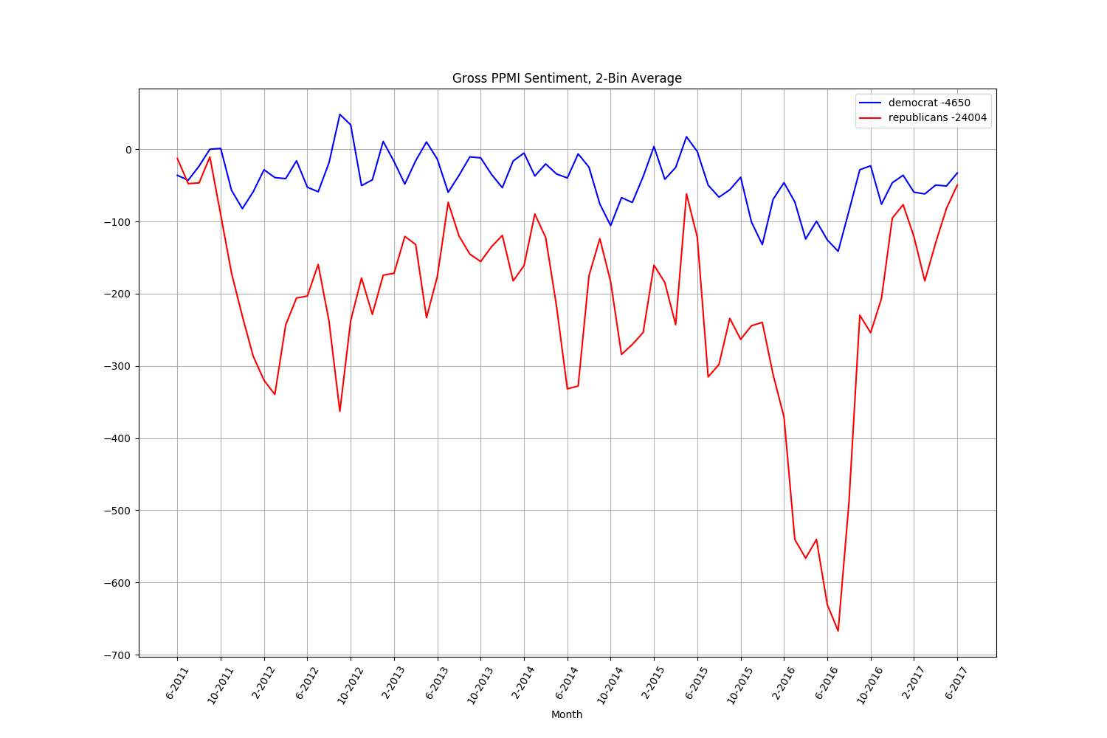

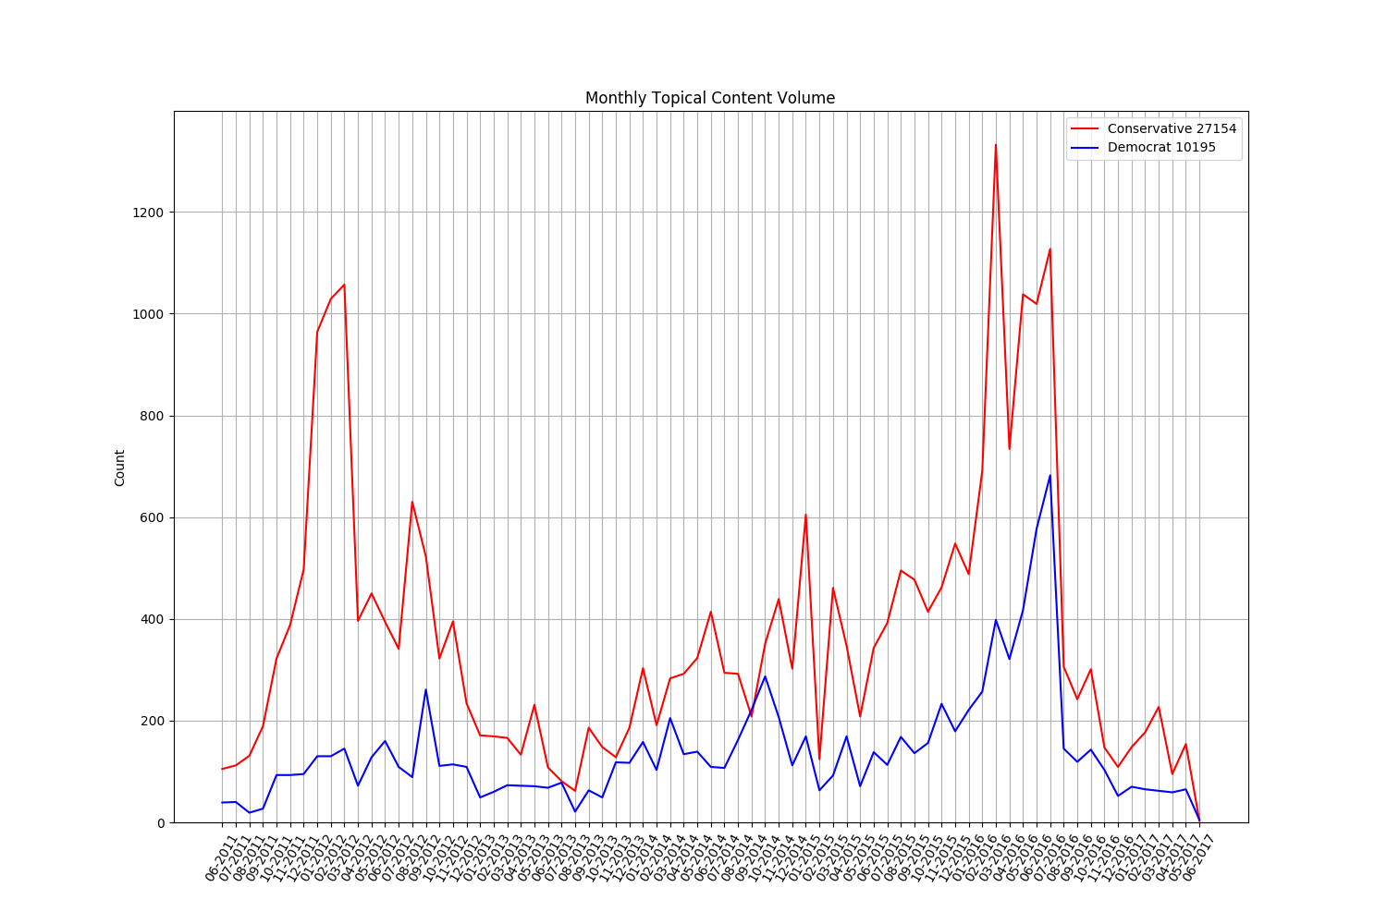

# 2016 Election Google News Link Analysis

## 2016 Partisan Content Link Distribution

The link distribution for partisan topics for topics $t3=\left\{democrat, liberal,progressive,dnc\right\}$ and $t4=\{republican,conservative,gop,rnc\}$ and the top 30 sources.

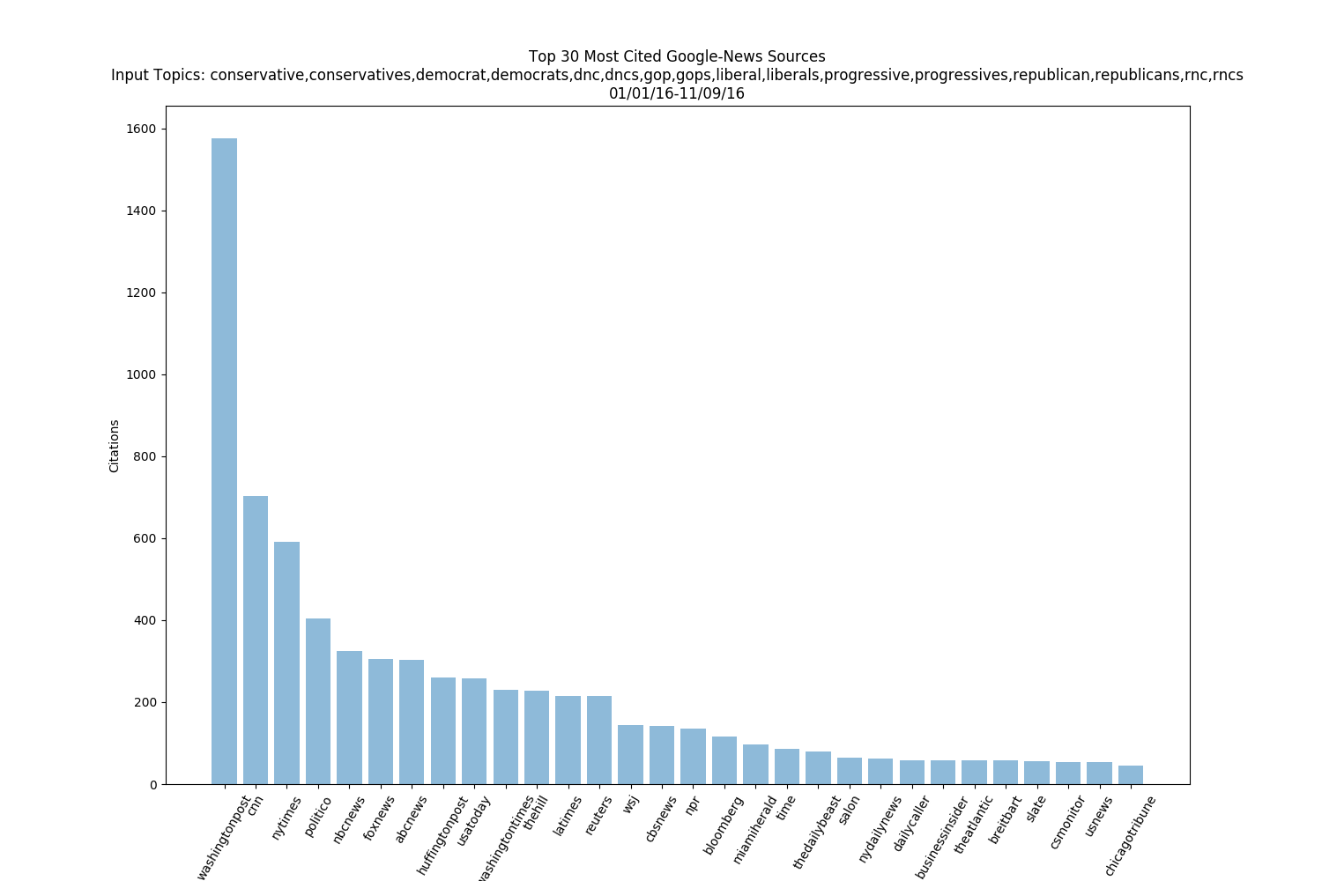

## 2016 Candidate Link Distribution

The link distribution for candidate topics $t1=\left\{donald,trump,djt\right\}$ and $t4=\{clinton,hillary,hrc\}$ and the top 30 sources.

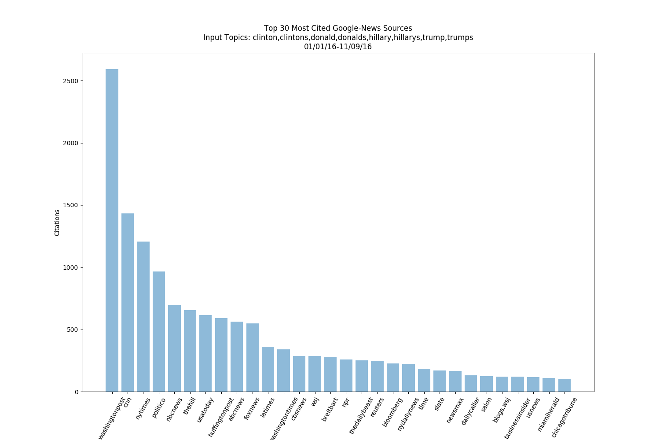

# Harvard Web Content Analysis

Content volume and PPMI sentiment analysis of topic sets $\{t1,t2\}$ and $\{t3,t4\}$, using the Harvard 2016 web-based election news dataset (Faris et al., 2017).

## Partisan Content Volume

## Candidate Content Volume

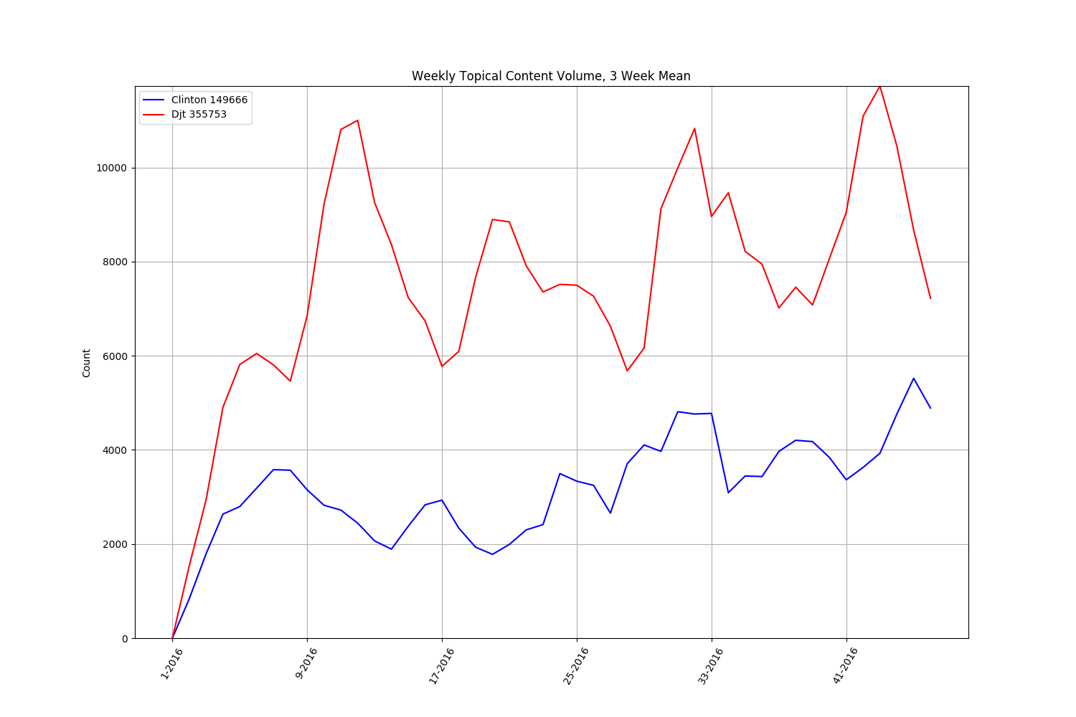

## Candidate Sentiment Analysis $t1=\left\{donald,trump,djt\right\}$ and $t2=\{clinton,hillary,hrc\}$

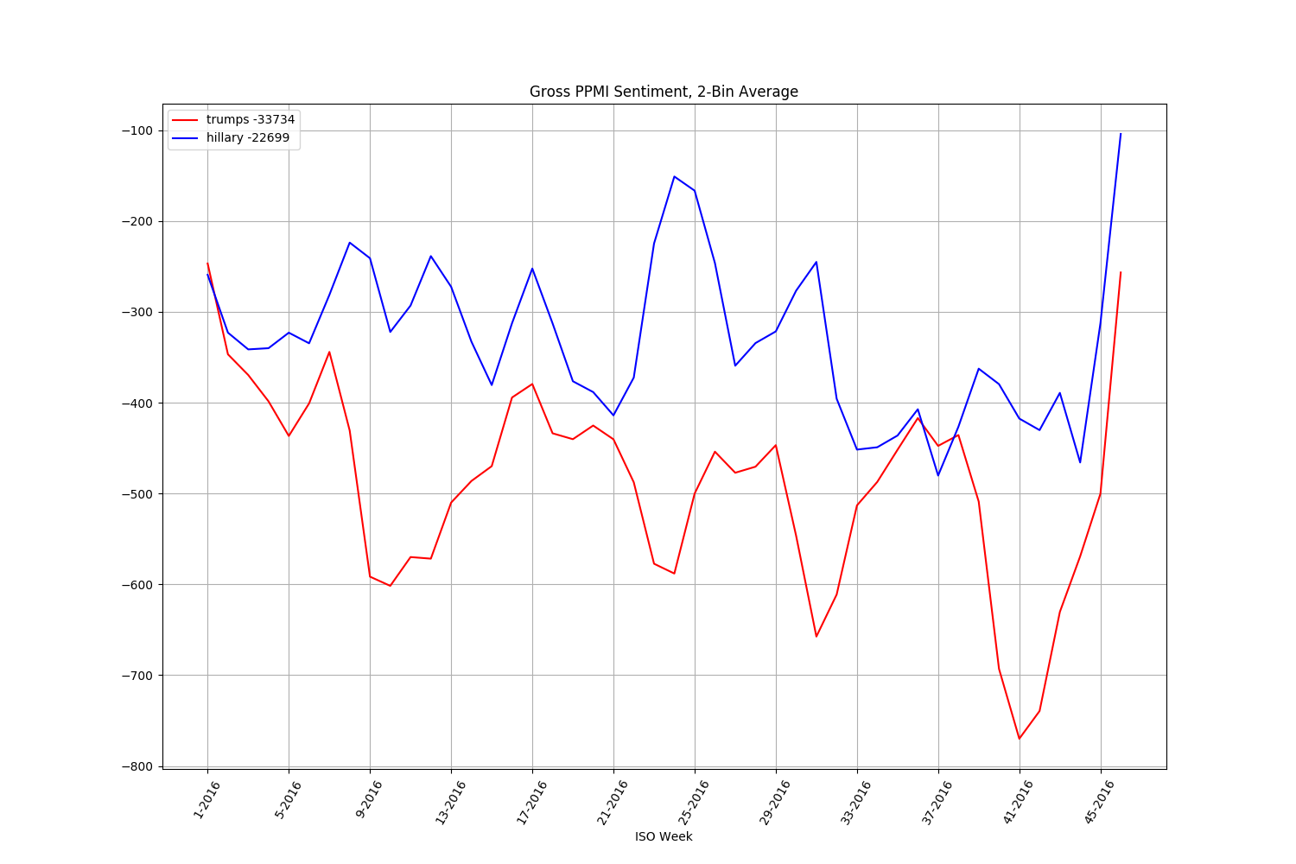

## Partisan Sentiment Analyses

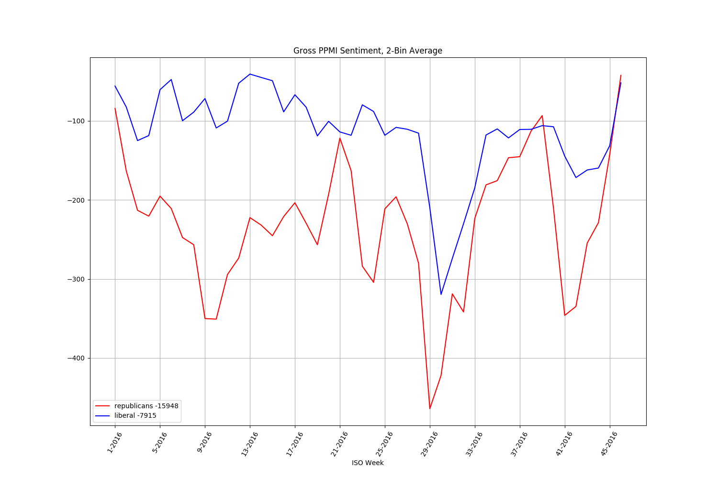

Sentiment analysis for topics $t3=\left\{democrat, liberal,progressive,dnc\right\}$ and $t4=\{republican,conservative,gop,rnc\}$.